San Diego Urban Timber
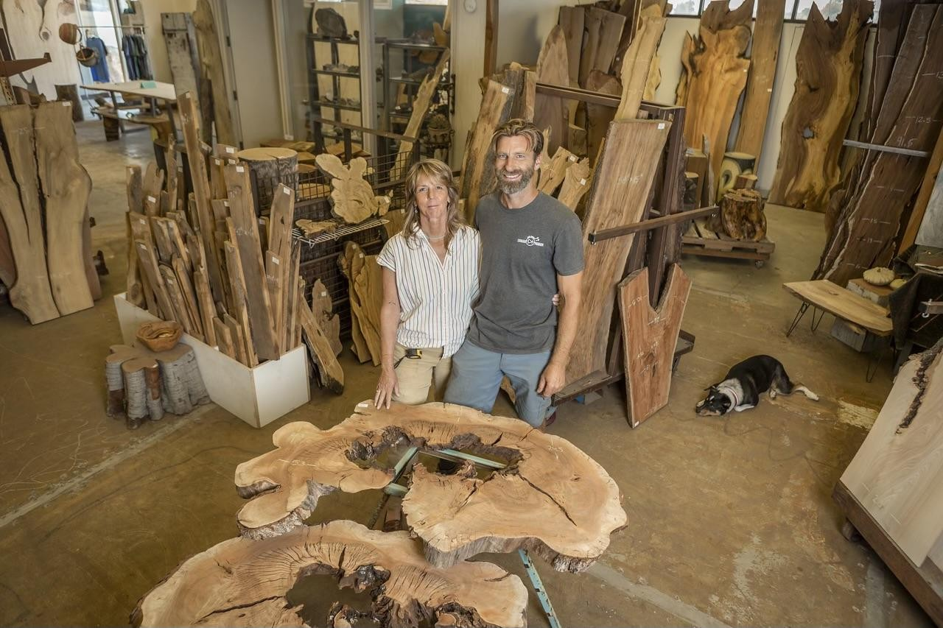
Owners: Jessica Van Arsdale & Daniel Herbst

HELLO, we are your Local Wood Hub here in San Diego!

We are a Mill, Build, & Design company that reclaim SD trees slated for the landfill and process them to create fine furniture, art, and materials for other woodworkers. We have been proudly doing this for over 16 years and at the end of last year became a Non-Profit!
Due to circumstances beyond our control we will be moving out of our Chula Vista location and are looking for strategic partners in relation to Urban Wood Utilization. The city gave notice that our location is to become a police impound yard and we must be out by September 1st 2024.
610 Bay Blvd is now our Storage Surplus Location and we simply cannot move with all this Beautiful material. Also, with our new I-Dry Vacuum Kiln we will surely create more material after the move.
As we look for a new home and/or new partners we are able to bless the SD community with Great Inventory Sales:
20% - 50% Off All Wood Material

This Months Holiday Sale:
April 19th + 20th - Earth, Arbor, Dan’s Birth-DAY HUGE BLOW OUT SALE: 30% - 60% Off All Wood Materials
Stay tuned for information via our website: www.sandiegourbantimber.com
If you have any questions please contact: info@sdurbantimber.com

New Hours of Operation: Saturdays 10:30am-5pm

