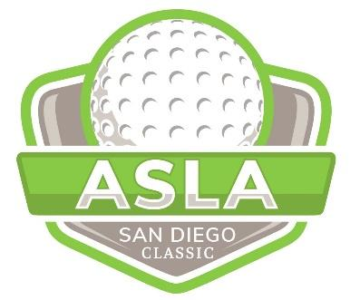

2024 ASLA SD ANNUAL GOLF TOURNAMENT
Monday Oct 28, 2024 @ 10:30 am
REGISTRATION FORM / SPONSORSHIP

First Name Last Name
Company Title
Phone No. Email

PLAY GOLF!

PLAYER REGISTRATION | QTY | COST | SUBTOTAL
Four-some (4 Players) |  | $640
Individual |  | $160
+ Super Tickets (extra contest  entries and drink ticket) |  | $30

SPONSOR GOLF!
*There is a limited quantity of each type of sponsorship, to be awarded on a first come, first served basis. If your desired level is no longer available, ASLA-San Diego will contact you with the option to re-select.

EVENT | DONATION | SUBTOTAL
Title Sponsor | $5000
Theme Sponsor | Swag ____________________

FOOD & BEVERAGES | DONATION | SUBTOTAL
Dinner | 1 @ $3000 or 2 @ $1500
Lunch | $1500
Beverage Cart | $800

CONTESTS | DONATION | SUBTOTAL
Team Score- 1st $200, 2nd $100, 3rd $75  *Sponsor presents prizes at dinner | $1500
Closest to the Pin- Men / Women | $500
Longest Drive- Women’s | $500
Longest Drive- Men’s | $500
Putting Contest | $500
Driving Range- Fathead signs | $800

INDIVIDUAL HOLES | PAR / AMENITY | DONATION | SUBTOTAL
Hole #1 | Par 4 / Alcohol | Park Planet | NA
Hole #2 | Par 4 | $800
Hole #3 | Par 5 | $800
Hole #4 | Par 3 | $800
Hole #5 | Par 4 | $800
Hole #6 | Par 3-4 / Alcohol | T.B. Penick & Sons | NA
Hole #7 | Par 3 | KOMPAN | NA
Hole #8 | Par 5 | $800
Hole #9 | Par 4 | $800
Hole #10 | Par 4 /Alcohol | Coast Recreation | NA
Hole #11 | Par 4 | $800
Hole #12 | Par 4 | $800
Hole #13 | Par 4 | $800
Hole #14 | Par 5 / Alcohol | $1000
Hole #15 | Par 3 | $800
Hole #16 | Par 4 | $800
Hole #17 | Par 3 / Closest to Pin | $800
Hole #18 | Par 5 | $800
TOTAL: $_____________
(for golf & sponsorship)
*Check here ______ if you need a table and chairs to be provided.
*Hole Sponsors are responsible for your own shade canopy.

PAYMENT OPTIONS
- ONLINE at https://bit.ly/aslasd2024golf
- CHECK: Make payable to “SD ASLA” and mail along with completed form to: San Diego ASLA, 1050 Rosecrans St, Ste B, San Diego, CA 92106

- CREDIT CARD: Credit card payments require an additional 5% processing fee + $.99 per transaction which will be added to the “Amount to Charge” & included in the final charged amount.

Name on Card ____________________________________________________________
Card Billing Address _______________________________________________________
Credit Card Type (circle): Mastercard Discover American Express Visa
Credit Card No. ___________________________ Exp Date _________ Card ID# _____
Signature ______________________________________________ Date ____________
Print Name __________________________________
For additional information, contact a Golf Committee Co-Chair:
Kathryn Kanaan, ASLA; KDA | #619-840-5174 | Kathryn@kda-landscapearchitects.com
Gregg Roesink; Hunter Industries/FX | #619-743-2766 | gregg.roesink@hunterindustries.com
Printing Courtesy of

