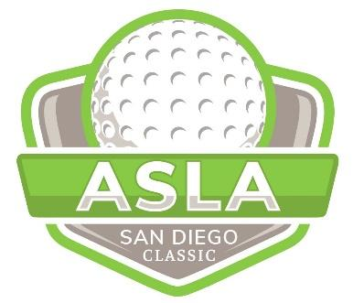
ASLA SD GOLF TOURNAMENT - Monday Oct 16, 2023
REGISTRATION FORM

CONTACT INFORMATION

First Name Company Phone No.
Player Names:
Last Name Title Email

Four-some (4 Players) |  | $600
Individual |  | $150
Super Tickets |  | $30

Title Sponsors Thank you Brightview and Rain Bird

Theme Sponsor | Welcome Gift (Hats) |  |  |  | Site One -  Green Tech
Dinner Sponsors |  |  |  |  | USA Shade &  Gale Pacific
Lunch Sponsors |  |  |  |  | Grant & Associates | OCS Lighting&Control
Beverage Cart Sponsor (1 cart still available) $600 Unique Recreation

Check Here if you need a table and chairs to be provided
Hole #1 – Par 4 (Alcohol) |  |  |  |  | Rain Bird
Hole #2 – Par 4 |  |  |  |  | Stepstone
Hole #3 – Par 5 – (Long Drive Hole) KOMPAN
Hole #4 – Par 3 $800
Hole #5 – Par 4 |  |  |  | $800
Hole #6 – Par 3/4 (Alcohol) |  |  |  |  | T.B. Penick
Hole #7 – Par 3 |  |  |  |  | $800
Hole #8 – Par 5 |  |  |  |  | $800
Hole #9 – Par 4 |  |  |  |  | Hunter/FX
Hole #10 – Par 4 (Alcohol) |  |  |  |  | Moon Valley
Hole #11 – Par 4 |  |  |  |  | $800
Hole #12 – Par 4 |  |  |  |  | $800
Hole #13 – Par 4 |  |  |  |  | $800
Hole #14 – Par 5 (Alcohol) |  |  |  |  | Westcoast Turf
Hole #15 – Par 3 |  |  |  |  | $800
Hole #16 – Par 4 |  |  |  |  | $800
Hole #17 – Par 3 (Closest to the Pin Hole) USA Shade and Gale Pacific
Hole #18 – Par 5 Tri Counties Bank

Team Score |  | $500
Closest to the Pin | Men’s / Women’s | $500
Longest Drive | Women’s | $500
Longest Drive | Men’s | $500
Putting Contest |  | $500

Driving Range (with Sponsor & Fat Head signs) $750

(Please note that there is a limited quantity of each type of sponsorship. Sponsorships will be awarded on a first come, first served basis. If the desired sponsorship level is no longer available you will be contacted by SD ASLA with the option to re-select.)
Hole Sponsors are responsible for your own shade canopy.

Name on Card Card Billing Address
Credit Card Type:
Mastercard
Discover
Amex
Visa
Credit Card No ________________________
Amount Before Processing Fee $ ___________
Exp Date ____ Card ID No _____
To expedite your registration or sponsorship pay online directly at this link:
https://www.eventbrite.com/e/asla-golf-tournament-tickets-549511713327
(Please note that credit card charges require an additional 5% processing fee + $.99 per
transaction which will be added to the “Amount to Charge” and will be included in the final
charged amount)

Signature Date Print Name

Mail the completed Registration Form and check to the address below:
San Diego ASLA Printing Courtesy of
1050 Rosecrans St, Ste B San Diego, CA 92106
(All checks should be made payable to “SD ASLA”)

For additional information contact a Co-Chair:
Jackie Higgins, ASLA - Golf Committee Co-Chair Phone: 619.218.4148
Company: Forever Balboa Park Email: Jackie@C2CLD.com

Gregg Roesink | Golf Committee Co-Chair Phone: 619.743-2766
Company: Hunter Industries/FX Email: gregg.roesink@hunterindustries.com

